

|  |  |  |  |  |  |  |  |  |
| --- | --- | --- | --- | --- | --- | --- | --- | --- |
|  | | | | | | | | |
|  | | Assignment . 2 | | | | |  | |
|  |  | | | | | | |  |
|  | | | |  |  | | | |
|  | | | | MujtabaSP22-BSE-036 |  | | | |
|  | | | | Nov 6, 2022—Discrete Structures—Mam Memoona Malik |  | | | |
|  | | |  | | |  | | |

Question . 1

(a)

p : It is below freezing.

q : It is snowing.

1. It is below freezing and snowing : (**p ^ q)**
2. It is below freezing but not snowing : **(p ^¬q)**
3. It is not below freezing and it is not snowing : **(¬p ^ ¬q)**
4. It is either snowing or below freezing (or both) : (**p v q)**
5. If it is below freezing, it is also snowing : (**p ^ q)**
6. Either it is below freezing or it is snowing, but it is not snowing if it is below freezing : (**p $⊕$ q)**
7. That it is below freezing is necessary and sufficient for it to be snowing : (**p $→$ q)**

(b)

p: The user enters a valid password.

q: Access is granted.

r: The user has paid the subscription fee.

1. “The user has paid the subscription fee, but does not enter a valid password.”:

**(r ^ ¬p)**

1. “Access is granted whenever the user has paid the subscription fee and enters a valid password.”:

**q $→$ (p ^ r)**

1. “Access is denied if the user has not paid the subscription fee.”:

**¬q $→$ ¬r**

1. “If the user has not entered a valid password but has paid the subscription fee, then access is granted.”:

**(¬p → ∧ r) → q**

Question . 2

(a)

Output of this circuit:

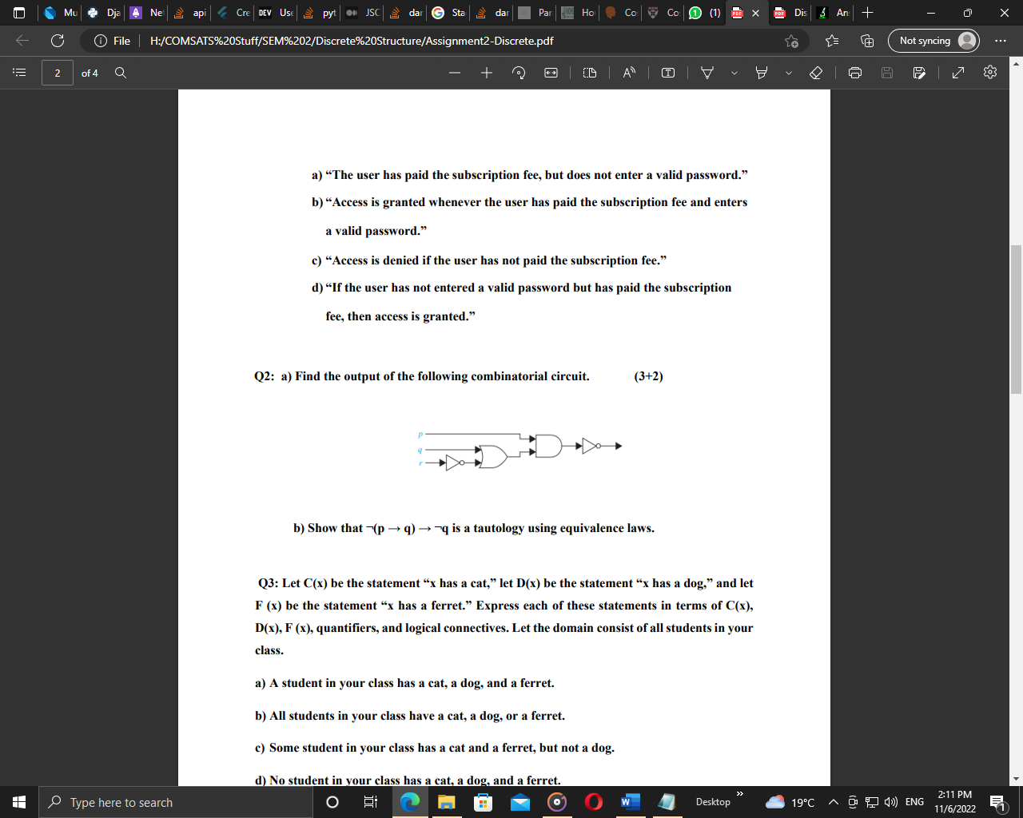

This circuit translates to: **¬((q v ¬r) ^ p)**

(b)

Show that ¬(p → q) → ¬q is a tautology using equivalence laws.

**Solution:**

|  |  |  |  |  |  |
| --- | --- | --- | --- | --- | --- |
| p | q | p → q | ¬(p → q) | ¬q | ¬(p → q) → ¬q |
| 1 | 1 | 1 | 0 | 0 | 1 |
| 1 | 0 | 0 | 1 | 1 | 1 |
| 0 | 1 | 1 | 0 | 0 | 1 |
| 0 | 0 | 1 | 0 | 1 | 1 |

Above table proves this relation.

Question . 3

Let C(x) be the statement “x has a cat,” let D(x) be the statement “x has a dog,” and let

F (x) be the statement “x has a ferret.” Express each of these statements in terms of C(x), D(x), F (x), quantifiers, and logical connectives. Let the domain consist of all students in your class.

1. A student in your class has a cat, a dog, and a ferret : $∃x (C(x)∧D(x)∧F(x))$
2. All students in your class have a cat, a dog, or a ferret : $∀x(C (x)∨D (x)∨F (x))$
3. Some student in your class has a cat and a ferret, but not a dog :

**∃x(C(x)∧F(x)∧¬D(x))**

1. No student in your class has a cat, a dog, and a ferret : $This is the negation of part(I):$ $¬∃x(C(x)∧D(x)∧F(x)).$
2. For each of the three animals, cats, dogs, and ferrets, there is a student in your class who has this animal as a pet :

**Here the owners of these pets can be different: (∃xC(x))∧(∃xD(x))∧(∃x F(x)). There is no harm in using the same dummy variable, but this could also be written, for example, as : (∃xC(x))∧(∃yD(y))∧(∃z F(z)**

Question . 4

(a)

What rule of inference is used in each of the following arguments?

1. Alice is a mathematics major. Therefore, Alice is either a mathematics major or a computer science major. **Answer: Addition.**
2. Jerry is a mathematics major and a computer science major. Therefore, Jerry is a mathematics major. **Answer: Simplification.**
3. If it is rainy, then the pool will be closed. It is rainy. Therefore, the pool is closed. **Answer: Modus ponens.**
4. If it snows today, the university will close. The university is not closed today. Therefore, it did not snow today. **Answer: Modus tollens.**
5. If I go swimming, then I will stay in the sun too long. If I stay in the sun too long, then I will sunburn. Therefore, if I go swimming, then I will sunburn. **Answer: Hypothetical syllogism.**

(b)

This argument form shows that the premises lead to the desired conclusion.

Step Reason

1. p →q Premise
2. ¬q →¬p Contrapositive of (1)
3. ¬p →r Premise
4. ¬q →r Hypothetical syllogism using (2) and (3)
5. r →s Premise
6. ¬q →s Hypothetical syllogism using (4) and (5)

(c)

**a) If I play hockey, then I am sore the next day. h → s**

**I use the whirlpool if I am sore. s → w**

**I did not use the whirlpool. ¬w**

**h: I play hockey.**

**s: I am sore.**

**w: I use the whirlpool.**

**b) If I work, it is either sunny or partly sunny. ∀x(W(x) → (S(x) ∨ P(x)))**

**I worked last Monday or I worked last Friday. W(Monday) ∨ W(Friday)**

**It was not sunny on Tuesday. ¬S(Tuesday)**

**It was not partly sunny on Friday. ¬P(Friday)**

**W(x): I work on x.**

**S(x): It is sunny on x.**

**P(x): It is partly sunny on x.**

**c) All insects have six legs. ∀x[I(x) → L(x)]**

**Dragonflies are insects. ∀x(D(x) → I(x))**

**Spiders do not have six legs. ∀x(S(x) → ¬L(x))**

**Spiders eat dragonflies. ∀x((S(x) ∧ D(y) → E(x, y))**

**I(x): x is an insect.**

**D(x): x is a dragonfly.**

**L(x): x has six legs.**

**S(x): x is a spider.**

**E(x, y): x eats y.**

**d) Every student has an internet account. ∀x(S(x) → I(x))**

**Homer does not have an internet account. ¬I(Homer)**

**Maggie has an internet account. I(Maggie)**

**S(x): x is a student.**

**I(x): x has an internet account.**

**e) All foods that are healthy to eat do not taste good. ∀x(H(x) → ¬G(x))**

**Tofu is healthy to eat. H(tofu)**

**You only eat what tastes good. ∀x(E(x) ↔ G(x))**

**You do not eat tofu. ¬E(tofu)**

**Cheeseburgers are not healthy to eat. ¬H(cheeseburger)**

**H(x): x is healthy to eat.**

**G(x): x tastes good.**

**E(x): You eat x**

**f) I am either dreaming or hallucinating. d ∨ h**

**I am not dreaming. ¬d**

**If I am hallucinating, I see elephants running down the road. h → e**

**d: I am dreaming.**

**h: I am hallucinating.**

**e: I see elephants running down the road.**

(d)

**a) Everyone enrolled in the university has lived in a dormitory. Mia has never lived in a dormitory. Therefore Mia has not enrolled in the university.**

**Let E(x) be the proposition that x is enrolled in the university, D(x) be the proposition that x has lived in a dorm, and D(M) be the proposition that Mia has lived in a dormitory.**

**Step Reason**

**1. ∀ x (E(x) → D(x)) Hypothesis**

**2. ¬D(M) Hypothesis**

**3. ¬E(M) Modus tollens using (3) and (2)**

**This is correct, using universal instantiation and modus tollens.**

**b) A convertible car is fun to drive. Isaac’s car is not a convertible. Therefore, Isaac’s car is not fun to drive.**

**This is not correct. After applying universal instantiation, it contains the fallacy of denying the hypothesis.**

**Let C(x) be the proposition that x is a convertible, D(x) be the proposition that x is fun to drive, and C(I) is the proposition that Isaac’s car is not a convertible.**

**Step Reason**

**1. ∀ x (C(x) → D(x)) Hypothesis**

**2. ¬ C(I) Hypothesis**

**3. ¬ C(I) → ¬ D(I) Fallacy because the inverse of (1) is not equivalent to (1)**

**(universal instantiation would say C(I), not ¬ C(I))**

**c) Quincy likes all action movies. Quincy likes the movie Eight Men Out. Therefore, Eight Men Out is an action movie.**

**Let x be the set of movies. Let A(x) be the proposition that x is an action movie, Q(x) be the proposition that Quincy likes the movie, and Q(E) be the proposition that Quincy likes Eight Men Out.**

**Step Reason**

**1. ∀ x (A(x) → Q(x)) Hypothesis**

**2. Q(E) Hypothesis**

**3. Q(E) → A(E) Fallacy because the converse of (1) is not equivalent to (1)**

**(universal instantiation would say A(E), not Q(E); it affirms**

**the conclusion according to the author)**

**d) All lobstermen set at least a dozen traps. Hamilton is a lobsterman. Therefore, Hamilton sets at least a dozen traps.**

**Let L(x) be the proposition that x is a lobsterman, and T(x) be the proposition that x sets at least a dozen traps, and L(H) be the proposition that Hamilton is a lobsterman.**

**Step Reason**

**1. ∀ x (L(x) → T(x)) Hypothesis**

**2. L(H) Hypothesis and instantiation**

**3. L(H) → T(H) Conclusion by modus ponens (correct, using universal**

**instantiation and modus ponens).**